**AMERICAN INTERNATIONAL UNIVERSITY BANGLADESH (AIUB)**

***FACULTY OF SCIENCE & TECHNOLOGY***



#### Course Title

**INTRODUCTION TO DATABASE**

**Spring 23-24**

### Section: G

**TITLE**

## Restaurant Management System

**Supervised By**

#### Saeeda Sharmeen

##### Submitted By: Group no: 03.

|  |  |
| --- | --- |
| **Name** | **ID** |
| Ahmed Jubayer | 22-49862-3 |
| Kazi Imtiaz | 22-49857-3 |
| Sumyah Jahan Pushpita | 22-49407-3 |
| Md Abu Rabbiul Riyad | 22-49864-3 |
| Riaz Raihan Niloy | 22-49881-3 |

|  |  |  |
| --- | --- | --- |
| **TABLE OF CONTENTS** | | |
| **SL NO** | **TOPICS** | **PAGE NO** |
|  | Title Page | 1 |
|  | Table of Content | 2 |
| **1** | Introduction | 3 |
| **2** | Case Study | 3 |
| **3** | E-R Diagram | 4 |
| **4** | Normalization | 5-10 |
| **5** | Finalization | 11 |
| **6** | Table Creation | 12-17 |
| **7** | Data Insertion | 18-24 |
| **8** | Query Test | 25-36 |
| **9** | Conclusion | 36 |  |
|  |  |  |
|  |  |  |

# Introduction

**Introduction:** The Restaurant Management System (RMS) presented in this project is acomprehensive solution designed to meet the evolving needs of the dynamic restaurant industry. With a focus on leveraging technology to enhance operational efficiency, the RMS aims to revolutionize how restaurants manage orders, inventory, employees, and customer interactions. Key features include streamlined order processing, efficient inventory management, employee and customer relationship management (CRM). By embracing the capabilities of the RMS, restaurant owners andstaff can expect improved productivity, reduced manual errors, and an enhanced overall dining experience for their customers in the competitive and fast-paced restaurant landscape.

# Case Study / Scenario

|  |  |  |
| --- | --- | --- |
| StudentID1: 22-49862-3 Name: Ahmed Jubayer | StudentID3: 22-49407-3 Name: Sumyah Jahan Pushpita | |
| StudentID2: 22-49857-3 Name: Kazi Imtiaz | StudentID4: 22-49864-3 Name: Md. Rabbiul Riyad | |
| StudentID5: 22-49881-3 Name: Riaz Raihan Niloy |  | |
| **CO2**: Understand the fundamental concepts underlying database systems and gain hands-on experience with ER diagram Case study | | |
| **PO-c2:** Develop process for complex computer science and engineering problems considering cultural and societal factors. | | Marks |

**Case Study**: A **restaurant** has a unique restaurant ID(**R_ID**)**,** restaurant name(**R_Name**), contact number(**R_contact**) and (**Address**). Many customers can go to one restaurant. A **customer** has unique customers ID(**Cus_ID**), customers Name (**Cus_Name**) and customer contact number (**Cus_contact**). A customer places many orders, the waiter take order. One waitercan take many orders. Then the waiter will serve the customer their order. One waiter can serve more than one customer. A **waiter** has unique waiter ID(**W_ID**) and waiter name(**W_Name**). An **order** has unique order number (**Order_NO**), Number of items (**No_Items**) and order time (**Ord_Time**). Then the order is prepared by the chef. Many chefs prepared many orders. Moreover, a **chef** has unique ID (**Chef_ID**) and chef name (**Chef_Name**).An order contains **food** (one order contains many food) which has unique food number (**Food_NO**), (**Quantity**), (**Price**), and (**Description**). Customers pay bills (one customers can pay more than one bill). The **bills** contain unique bill number(**B_NO**), price(**B_Price**), (**Order_Detail**), and (**vat**). A restaurant has one manager,**Manager** has unique manager ID(**Man_ID**) and manager name(**Man_Name**).One manager can manage many waiter.

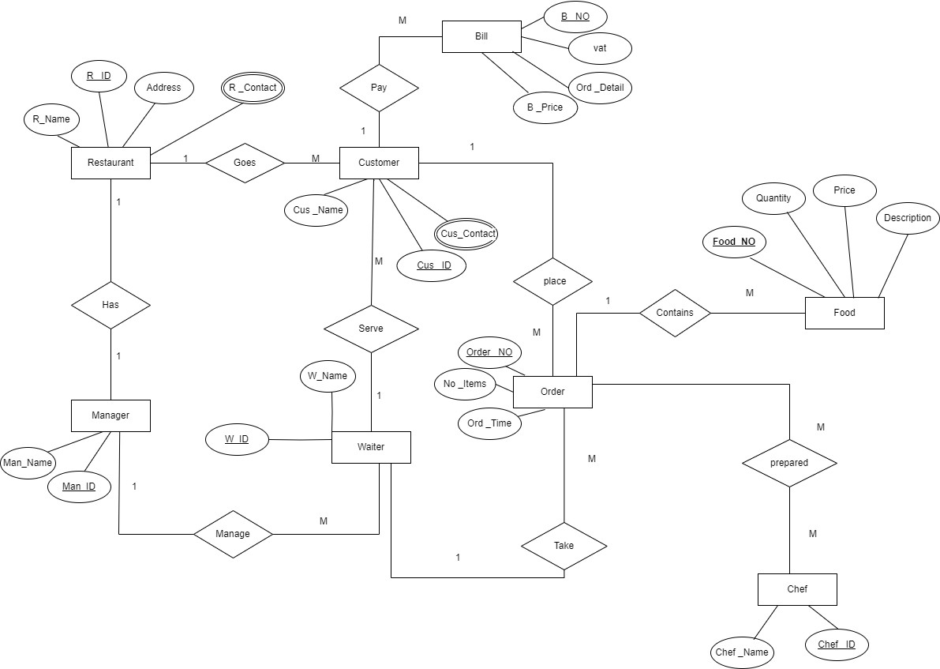

Fig 1: E-R Diagram for Restaurant Management System

# Normalization:

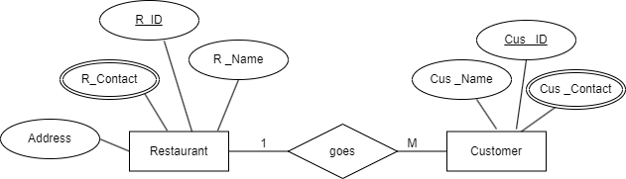

Fig 2: Relation between Restaurant and Customer

##### Goes:

UNF:(**Cus _ID**, Cus _Name, Cus _Contact**, R_ID**, R _Name, Address, R _Contact) 1NF:

Customer: **Cus _ID**, Cus_ Name, Cus_Contact Restaurant: **R _ID**, R_Name, Address, R _Contact 2NF:

Customer: **Cus _ID**, Cus _Name, Cus_Contact,R_ID(FK) Restaurant: **R_ID**, R _Name, Address, R_Contact

3NF:

Customer: **Cus _ID**, Cus _Name, Cus_Contact,R_ID(FK)

Restaurant: **R_ID**, R_Name, R _Contact

Restaurant INFO: R _Name, Address

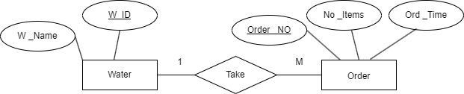

Fig 3: Relation between Waiter and Order

##### Take:

UNF:(**W_ID**, W _Name, Order _NO, No _Items, Ord _Time) 1NF:

Waiter: **W _ID**, W_Name

Order: **Order _NO**, No _Items, Ord _Time 2NF:

Waiter: **W_ID**, W _Name, Order _No (FK) Order: **Order _NO**, No _Items, Ord _Time 3NF:

Waiter: **W_ID**, W _Name, Order _No (FK) Order: **Order _NO**, No _Items OrderINFO: No _Items, Ord _Time

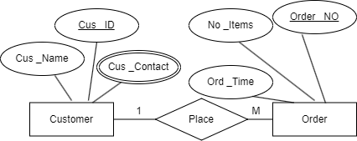

Fig 4: Relation between Customer and Order

##### Place:

UNF: **Cus _ID**, Cus _Name, Cus _Contact, **Order _NO**, No _Items, Ord _Time 1NF:

Customer: **Cus _ID**, Cus _Name, Cus _Contact Order: **Order _NO**, No _Items, Ord _Time 2NF:

Customer: **Cus_ID**, Cus _Name, Cus_Contact

Order: **Order_NO**, No_Items, Ord_Time, Cus_ID(FK) 3NF:

Customer: **Cus_ID**, Cus_Name, Cus_Contact Order: **Order_NO**, No_Items, Cus_ID(FK) OrderINFO: No_Items, Ord_Time

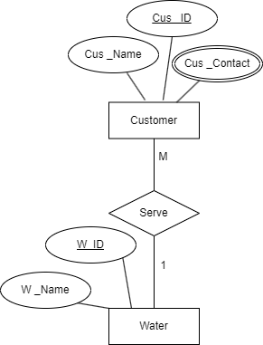

##### Serve:

Fig 5: Relation between Customer and Waiter

UNF:(Customer: **Cus _ID**, Cus _Name, Cus _Contact, **W_ID**, W _Name) 1NF:

Customer: **Cus _ID**, Cus _Name, Cus _Contact Waiter: **W_ID**, W_Name

2NF:

Customer: **Cus _ID**, Cus _Name, Cus _Contact Waiter: **W _ID**, W _Name, Cus _ID(FK)

3NF:

Same As 2NF

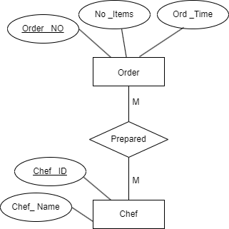

Fig 6: Relation between Order and Chef

##### Prepared

UNF:(**Chef _ID**, Chef_ Name, Order _NO, No _Items, Ord _Time) 1NF:

Chef: **Chef _ID**, Chef _Name

Order: Order _NO, No _Items, Ord _Time 2NF:

Chef: **Chef _ID**, Chef _Name, Order _NO(FK) Order: **Order _NO**, No _Items, Ord _Time 3NF:

Chef: **Chef _ID**, Chef _Name, Order _NO(FK) Order**: Order _NO**, No _Items

OrderINFO: No _Items, Ord _Time

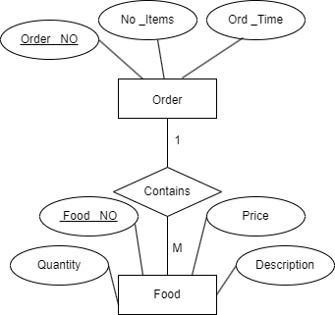

Fig 7: Relation between Order and Food

##### Contains

UNF:(**Order_ NO**, No _Items, Ord _Time, **Food _NO**, Quantity, Price)

1NF:

Order: **Order _NO**, No _Items, Ord _Time Food: **Food _NO**, Quantity, Price,

2NF:

Order: **Order_NO**, No _Items, Ord _Time

Food: **Food_NO**, Quantity, Price, Description, Order _NO(FK) 3NF:

Order: **Order_NO**, No_Items

OrderINFO: No _Items, Ord _Time

Food: **Food_NO**, Quantity, Description, Order_NO(FK) FoodDetails: Quantity,Price, Food_NO(FK)

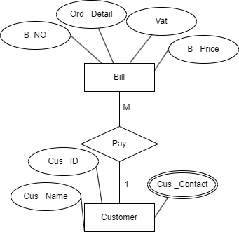

##### Pay

Fig 8: Relation between Customer and Bill

UNF:(Customer: **Cus _ID**, Cus _Name, Cus _Contact, **B_NO**, Vat, Ord _Detail, B _Price) 1NF:

Customer: **Cus _ID**, Cus _Name, Cus _Contact Bill: **B _NO**, Vat, Ord _Detail, B_Price

2NF:

Customer: **Cus _ID**, Cus _Name, Cus _Contact

Bill: **B_ NO**, Vat, Ord _Detail, B _Price, Cus _ID(FK) 3NF:

Customer: **Cus _ID**, Cus _Name, Cus _Contact Bill: **B_NO**, Ord_Detail, B_Prcie, Cus_ID(FK) BillDescription: B_Price, Vat

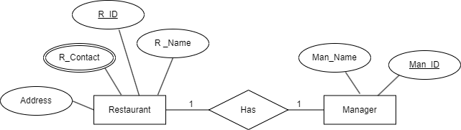

Fig 9: Relation between Restaurant and Manager

##### Has

UNF:(**R_ID**, R _Name, Address, R_Contact, **Man_ID**, Man_Name) 1NF:

Restaurant: **R_ID**, R_Name, Address, R_Contact Manager: **Man_ID**, Man _Name

2NF:

Restaurant: **R_ID**, R_ Contact, Man_ID(FK) Manager: **Man_ID**, Man_Name

#### Restaurant INFO: R _Name, Address

ManagerDetails: **R_ID**, Man_ID(FK) 3NF: Same as 2NF

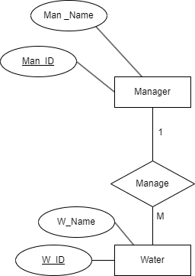

Fig 10: Relation between Manager and Waiter

##### Manage

UNF:(**Man_ID**, Man_Name, **W_ID**, W_Name) 1NF:

Manager: **Man_ID**, Man _Name Waiter: **W_ID**,W_Name

2NF:

Manager: **Man_ID**,Man_Name

Waiter: **W_ID**, W_Name, Man_ID(FK) 3NF: Same as 2NF

**Finalization:**

1. Restaurant: **R_ID**, R_Name, R _Contact
2. RestaurantINFO: R _Name , Address
3. Waiter**: W_ID**, W _Name, Order _No (FK)
4. Order: **Order _NO**, No _Items
5. OrderINFO: No _Items , Ord _Time
6. Customer: **Cus _ID**, Cus _Name, Cus _Contact, R_ID(FK)
7. Order: **Order _NO**, No _Items, Cus _ID(FK)
8. ~~OrderINFO: No _Items , Ord _Time~~
9. ~~Customer:~~ **~~Cus _ID~~**~~, Cus _Name, Cus _Contact~~
10. Waiter**: W _ID**, W _Name, Cus _ID(FK)
11. Chef: **Chef _ID**, Chef _Name, Order _NO(FK)
12. ~~Order:~~ **~~Order _NO~~**~~, No _Items~~
13. ~~OrderINFO: No _Items , Ord _Time~~
14. ~~Order:~~ **~~Order_NO~~**~~, No_Items~~
15. ~~OrderINFO: No _Items , Ord _Time~~
16. Food: **Food_NO**, Quantity, Description, Order_NO(FK)
17. FoodDetails: Quantity, Price, Food_NO(FK)
18. ~~Customer:~~ **~~Cus _ID,~~** ~~Cus _Name, Cus _Contact~~
19. Bill: **B_NO**, Ord_Detail, B_Prcie, Cus_ID(FK)
20. BillDescription: B_Price,Vat
21. ~~Restaurant:~~ **~~R_ID~~**~~, R_Name, R_ Contact~~
22. Manager: **Man_ID**, Man_Name
23. ~~RestaurantINFO: R _Name , Address~~
24. ManagerDetails: **R_ID**, Man_ID(FK)
25. ~~Manager:~~ **~~Man_ID~~**~~, Man_Name~~
26. Waiter: **W_ID,** W_Name, Man_ID(FK)

# Table Creation (DDL Operations)

|  |  |  |
| --- | --- | --- |
| StudentID1: 22-49862-3 Name: Ahmed Jubayer | StudentID3: 22-49407-3 Name: Sumyah Jahan Pushpita | |
| StudentID2: 22-49857-3 Name: Kazi Imtiaz | StudentID4: 22-49864-3 Name: Md. Rabbiul Riyad | |
| StudentID5: 22-49881-3 Name: Riaz Raihan Niloy |  | |
| **CO4**: Creating DML, DDL using Oracle and connection with ODBC/JDBC for existing JAVA application | | |
| **PO-e-2:** Use modern engineering and IT tools for prediction and modeling of complex computer science and engineering problem | | Marks |

# Table Creation

* 1. Restaurant Table

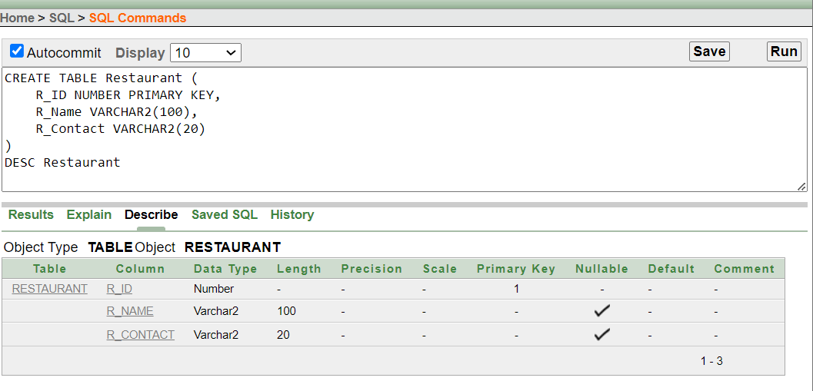

* 1. RestaurantINFO Table

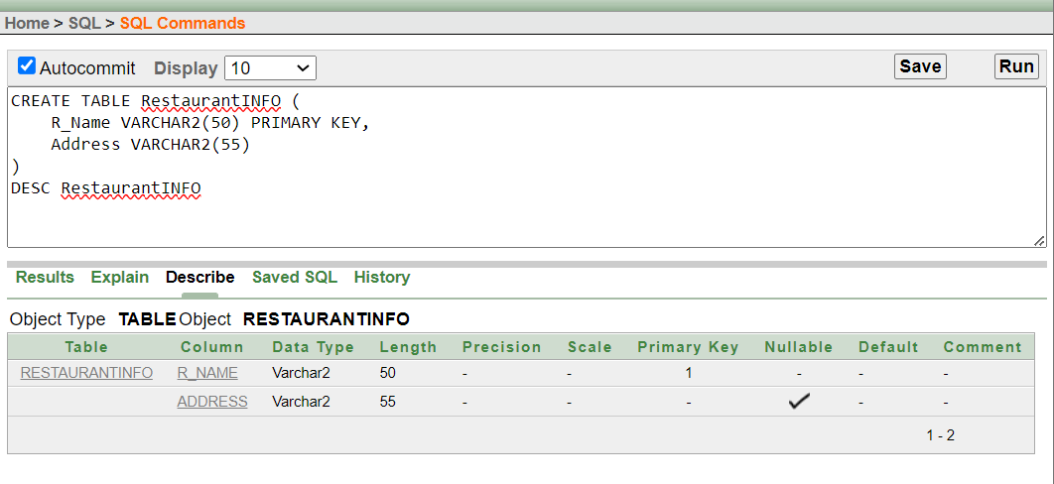

* 1. Customer Table

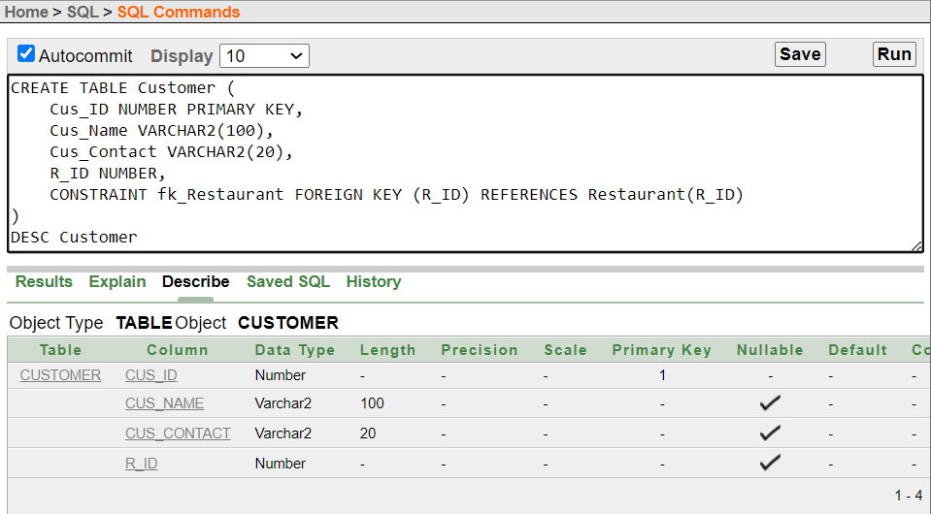

* 1. Waiter Table

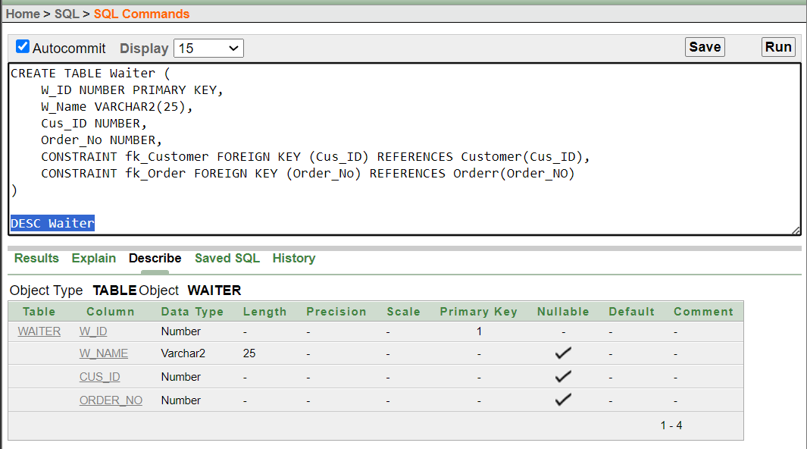

* 1. Orderr Table

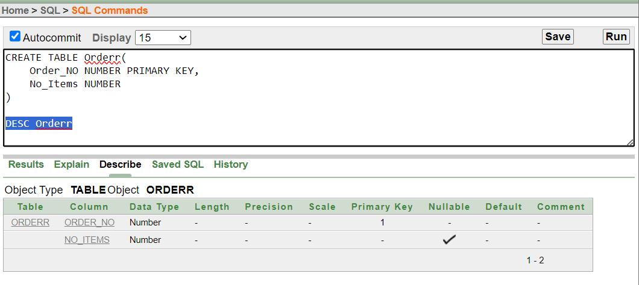

* 1. OrderINFO Table

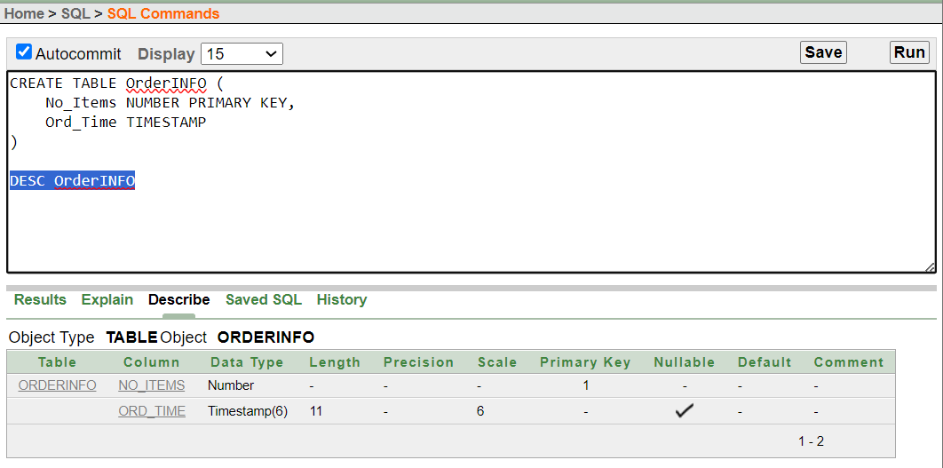

* 1. Food Table

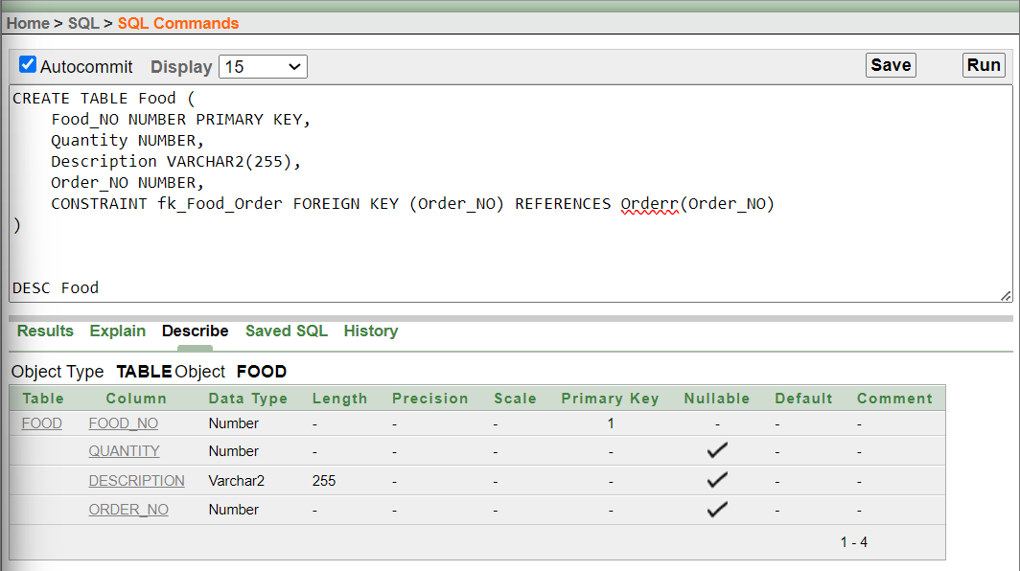

* 1. FoodDetails Table

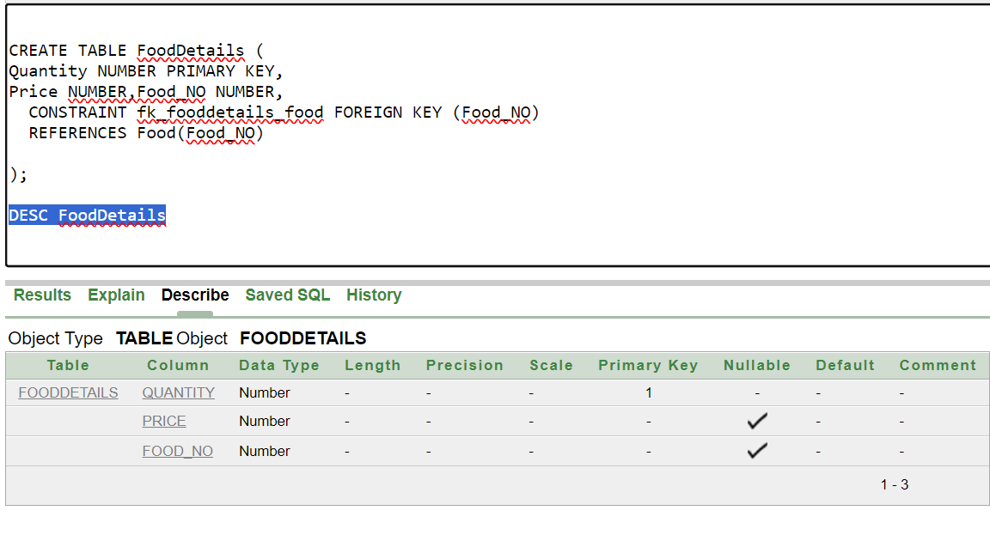

* 1. Chef Table

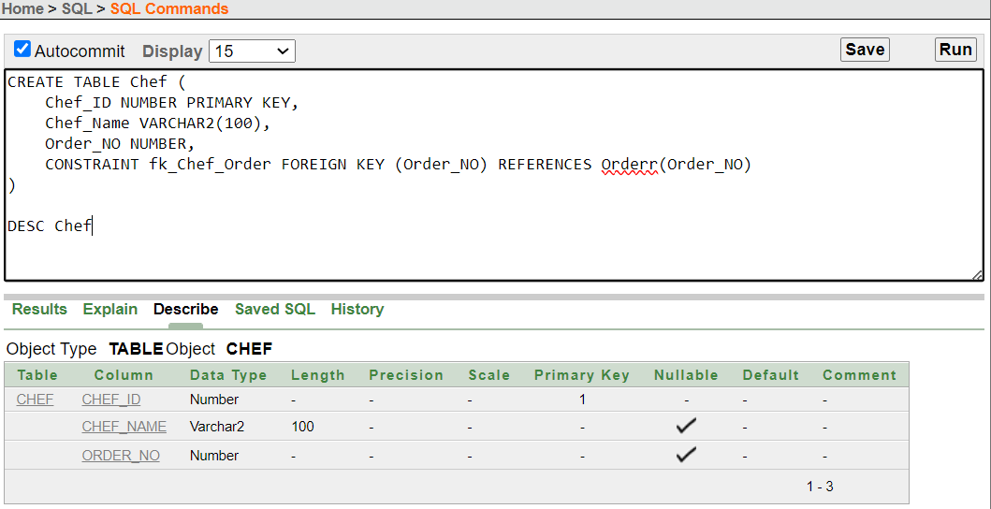

* 1. Bill Table

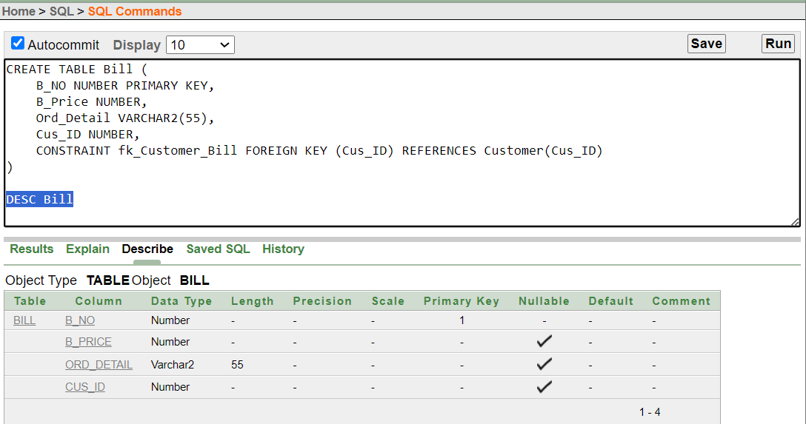

* 1. BillDescription Table

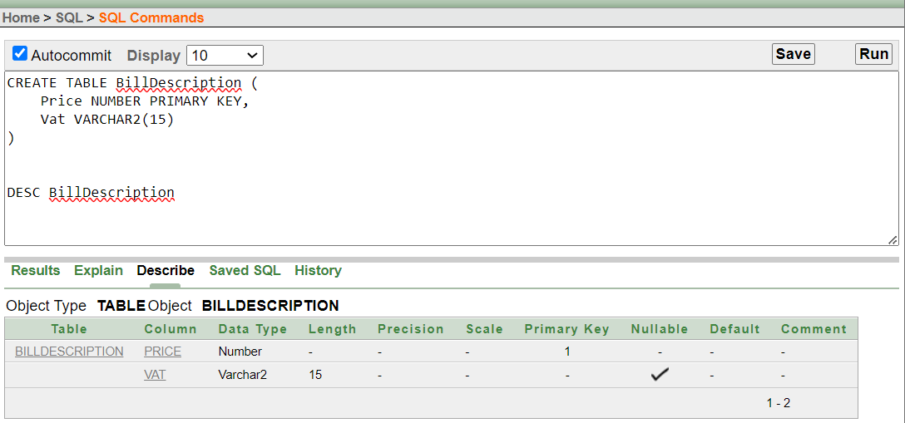

* 1. Manager Table

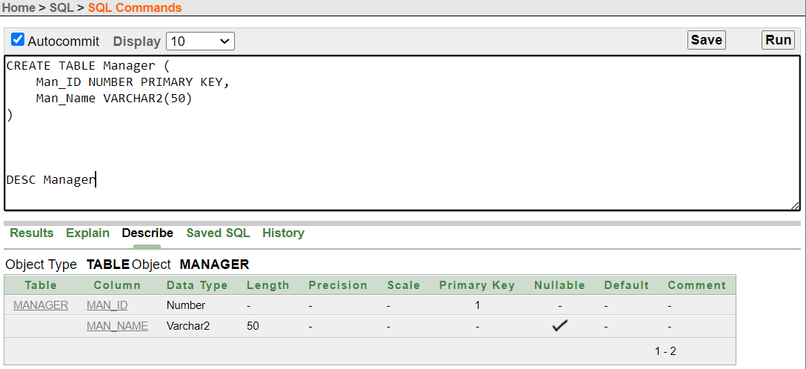

* 1. ManagerDetails Table

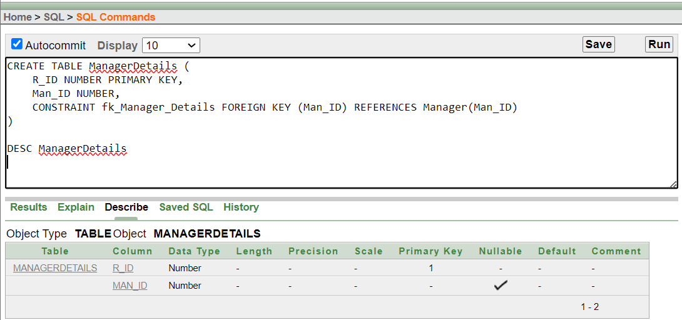

* 1. WaiterManage Table

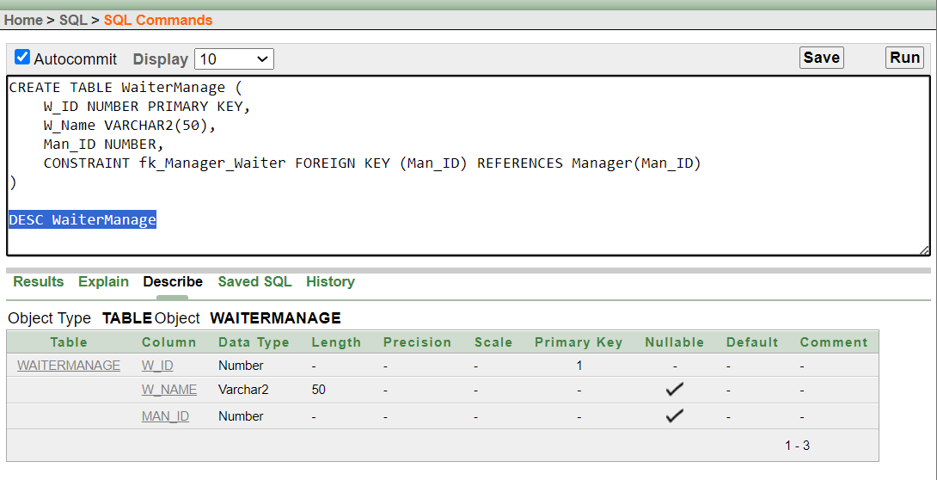

# Data Insertion

* + 1. 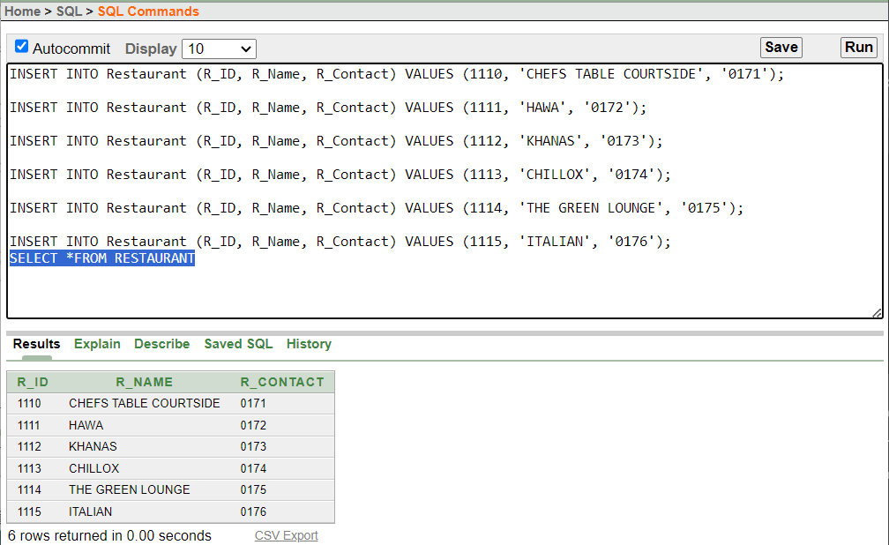Value Insertion of table Restaurant.
    2. Value Insertion of table Customer.

* + 1. 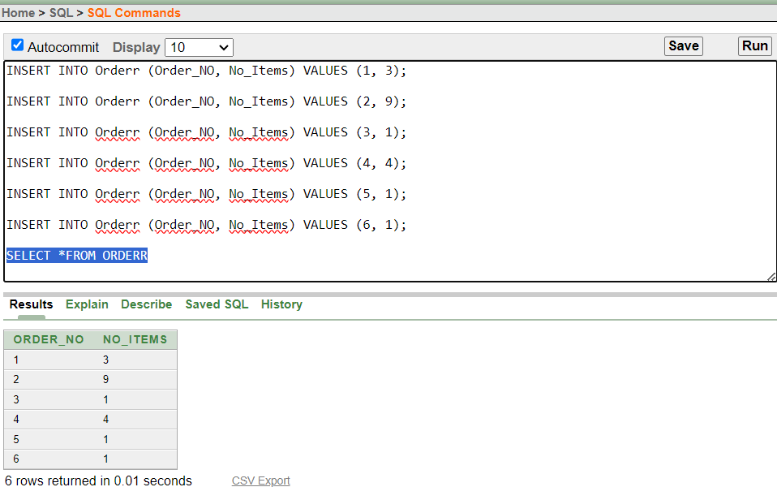Value Insertion of table Orderr.
    2. Value Insertion of table OrderINFO.

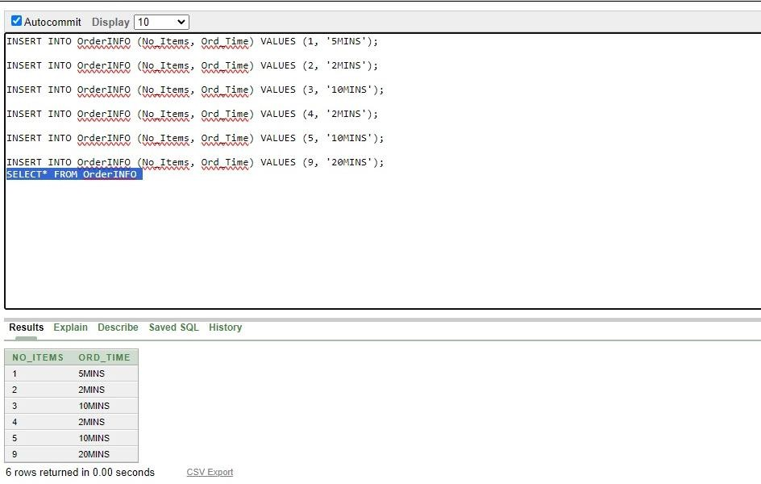

* + 1. 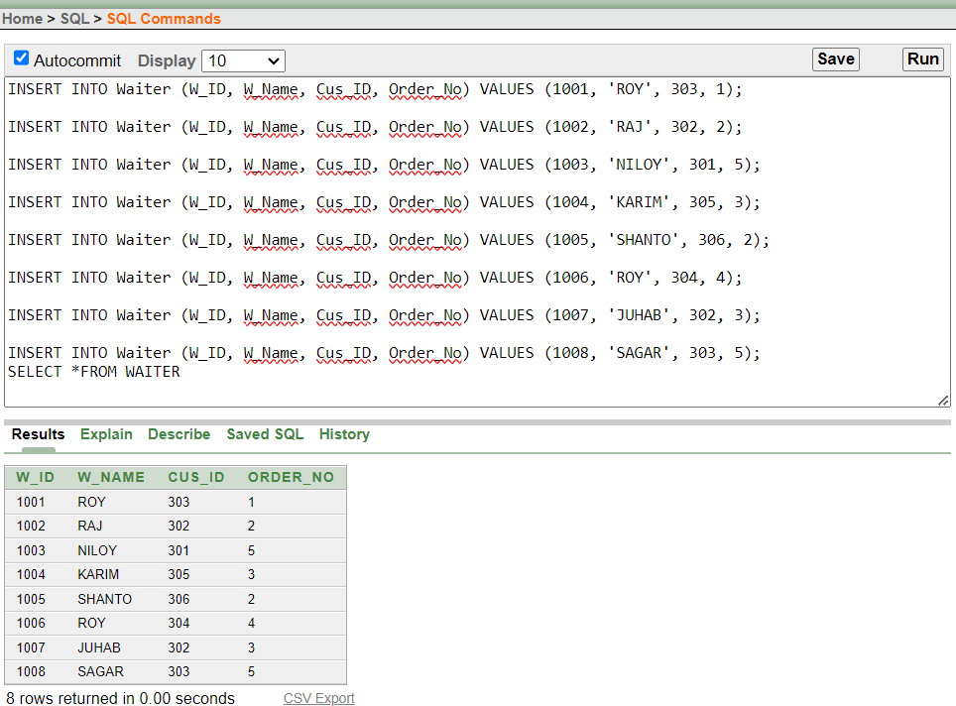Value Insertion of table Waiter.
    2. Value Insertion of table RestaurantINFO.

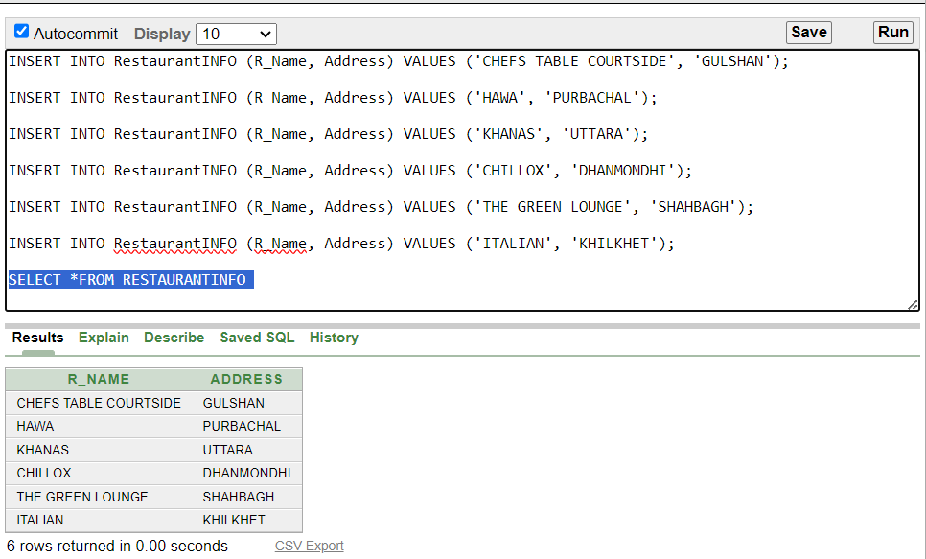

* + 1. 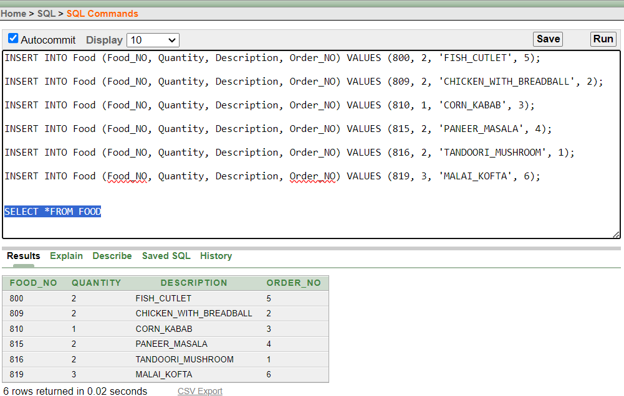Value Insertion of table Food.
    2. Value Insertion of table Chef.

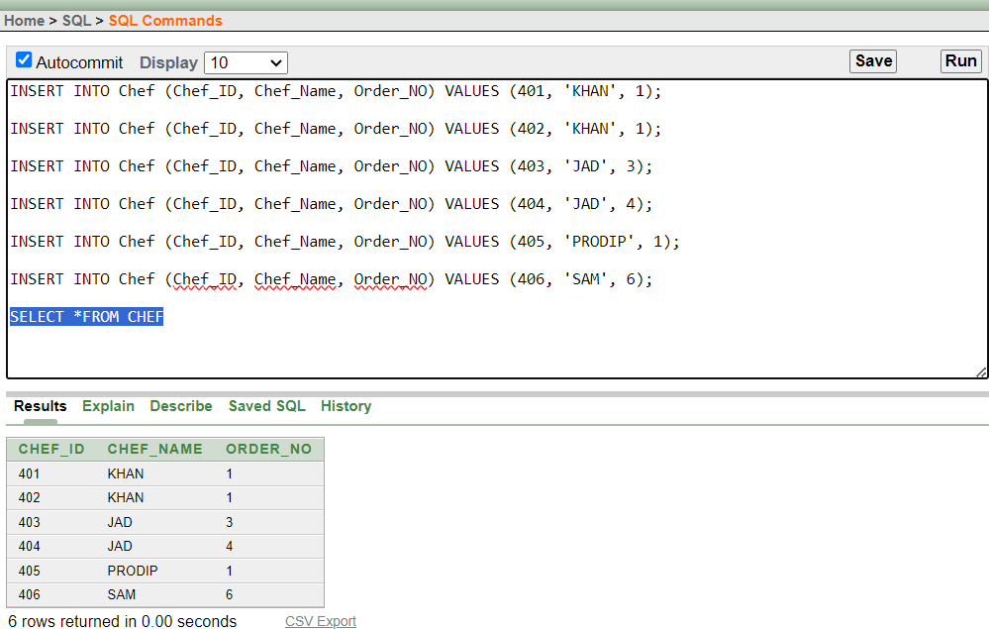

* + 1. 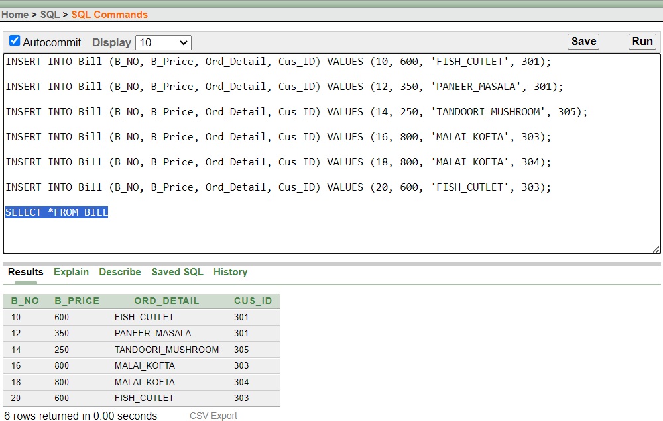Value Insertion of table Bill.
    2. Value Insertion of table BillDescription.

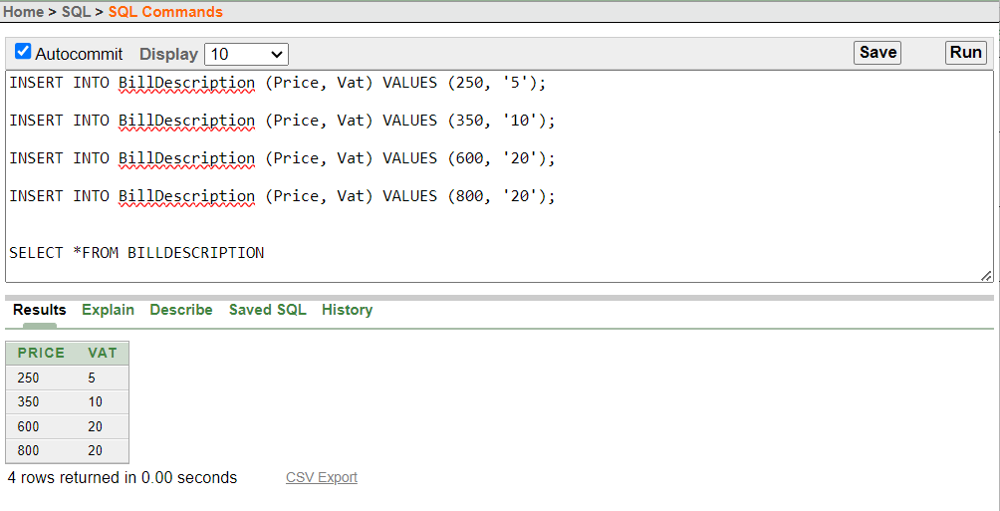

* + 1. 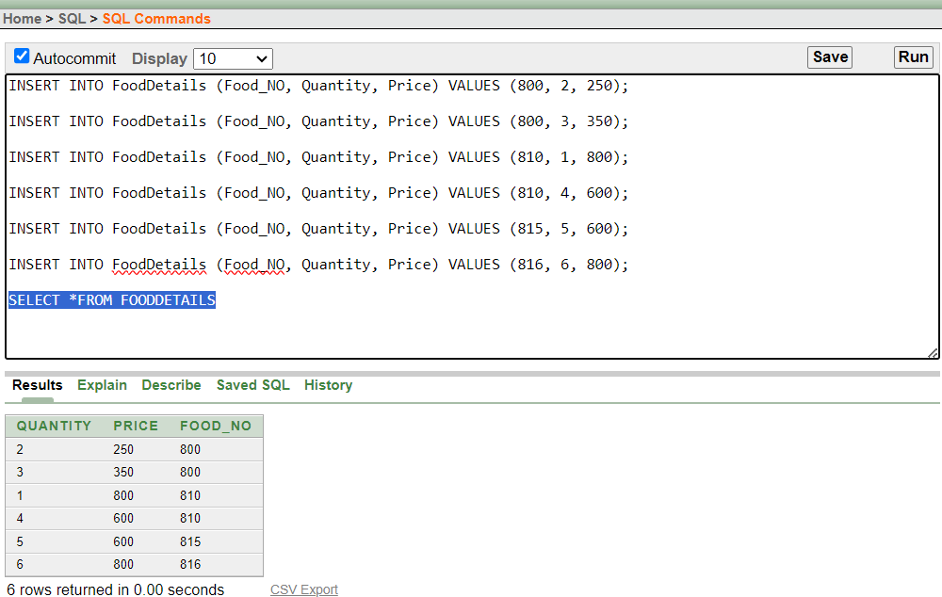Value Insertion of table FoodDetails.
    2. Value Insertion of table ManagerDetails.

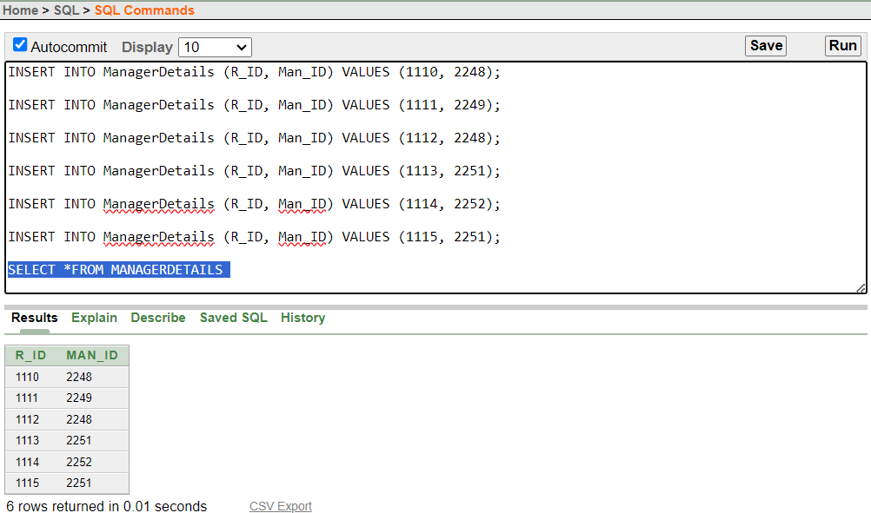

* + 1. 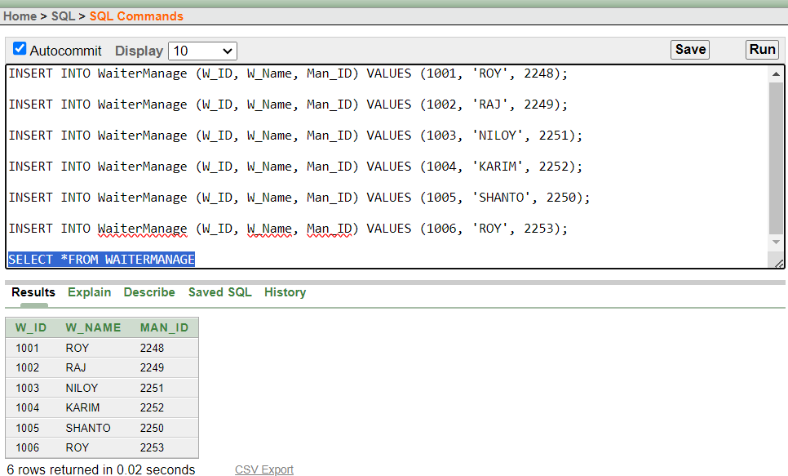Value Insertion of table WaiterManage.
    2. Value Insertion of table Manager.

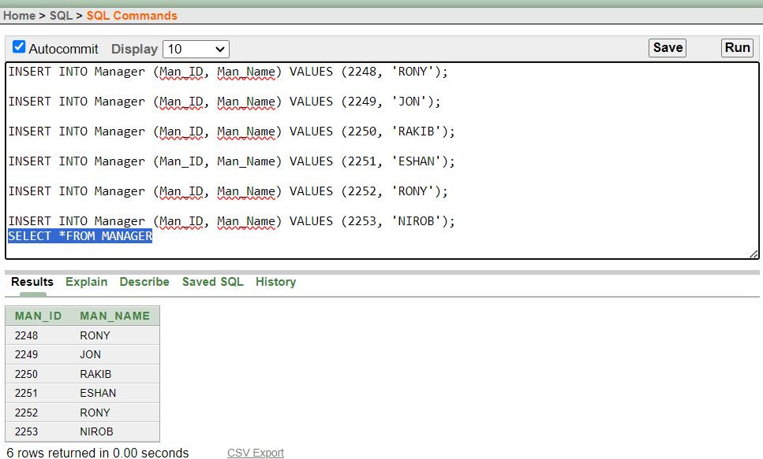

# QUERY TEST

## Simple Query:

1. **Question:** Retrieve the price and VAT information from the BillDescription table for items with a price between $350 and $800.

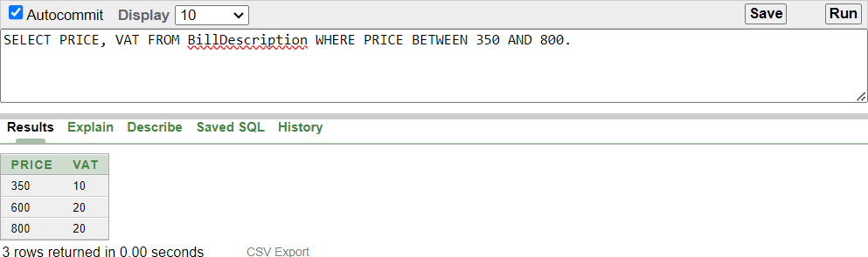

1. **Question:** Retrieve the Restaurant ID and Restaurant Name for the restaurant with the contact number '0171'.

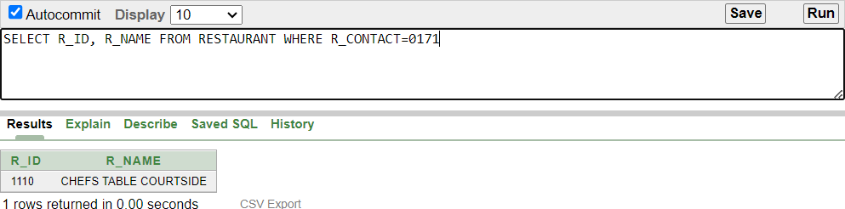

1. **Question:** List the Customer Names and IDs for customers whose names contain 'A' and 'R' together or have a name starting with any character followed by 'I’.

1. **Question:** List the Food Numbers, Quantities, and Prices for items where the Food Number is 815 or greater, or the Price is 350

1. **Question:** Display Waiter Name, Waiter ID and Order Number sorted by descending order of their associated order numbers?

1. **Question:** Retrieve Waiter Name, Waiter ID, and Order Number, order by ascending Order Numbers and then in descending Waiter IDs within each order.

1. **Question:** Display the Food Number, Quantity, and a concatenated string of Description and Order Number as (ORDEREDFOODNAME) for each record in the FOOD table?

1. **Question:** Retrieve the Restaurant Name and Restaurant ID for restaurants whose names start with 'HAWA'.

1. **Question:** Provide the Manager Name (MAN_Name) and the length of each manager's name (LENGTH) from the MANAGER table.

1. **Question:** Retrieve the Manager ID and a modified version of the Manager Name (NEW_MANAGER_NAME) removing the letter 'B' from the name, for managers with the original name 'RAKIB.

1. **Question:** Retrieve the original food Description and a modified version (MODIFY_FOOD_DESCRIPTION) using the REPLACE function to replace 'CUTLET' with 'FRI' for items with the original description 'FISH_CUTLET.’

**13.Question:** Name, and the position (index) of the letter 'R' in the Waiter Name from the WAITER table.

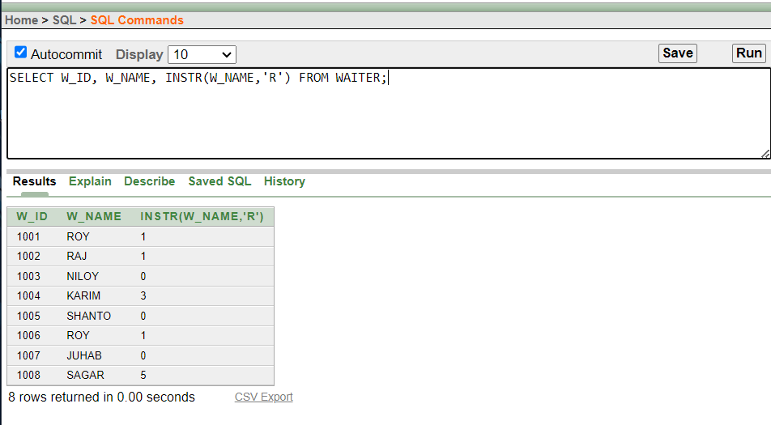

**Aggregate Query**

1. **Question:** Retrieve the maximum Bill Price from the "Bill" table.

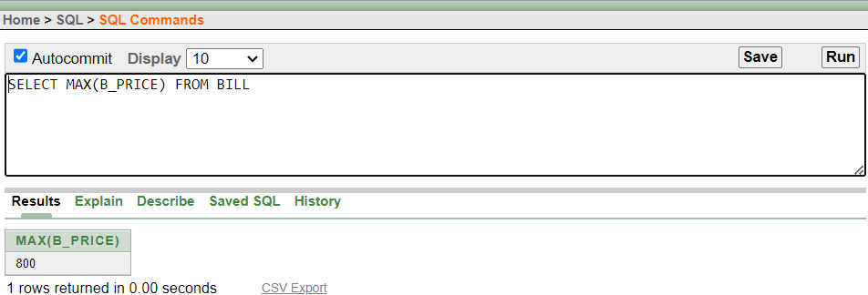

1. **Question:** Retrieve the minimum Bill Price from the "Bill" table.

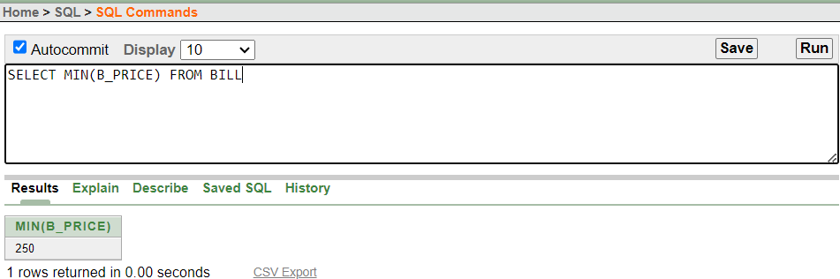

1. **Question:** Calculate the average of the maximum Bill Price for each distinct Bill Price group in the "Bill" table.

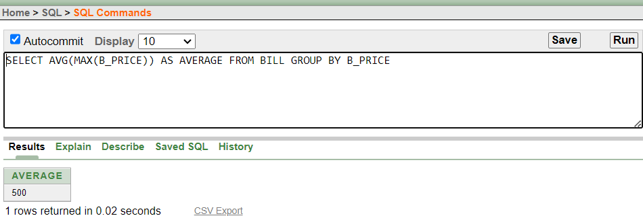

1. **Question:** Calculate the average, maximum, minimum, and total (sum) Price for items in the "BillDescription" table where the VAT is either 5 or 20.

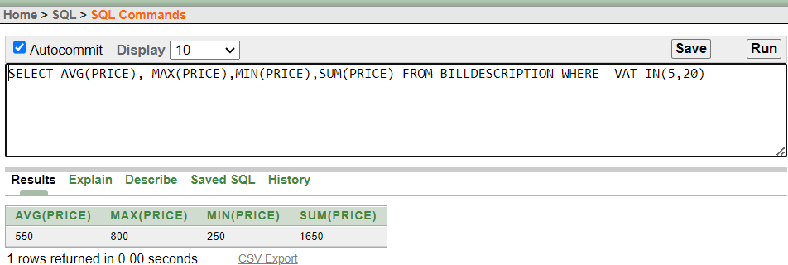

## Subquery (Multiple-row subquery and Single -row subquery)

1. **Question:** Display the names of waiters who handled orders placed after the order was handled by Waiter ID 1004.

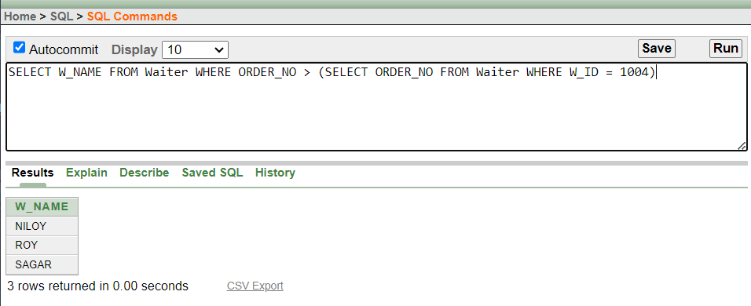

1. **Question:** Retrieve the Customer ID of those who placed orders with Waiter Name 'RAJ’.

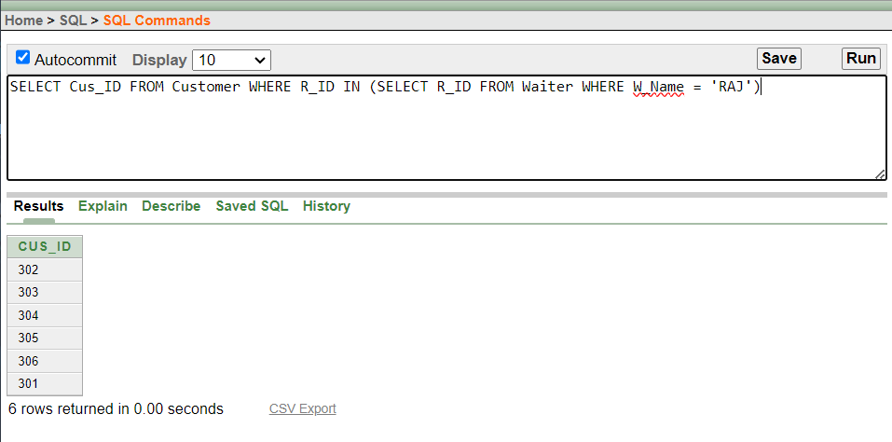

1. **Question:** Retrieve the Food Number and Description from the "Food" table for items where the quantity is less than any item with a quantity of 3 and the order number is not equal to 2.

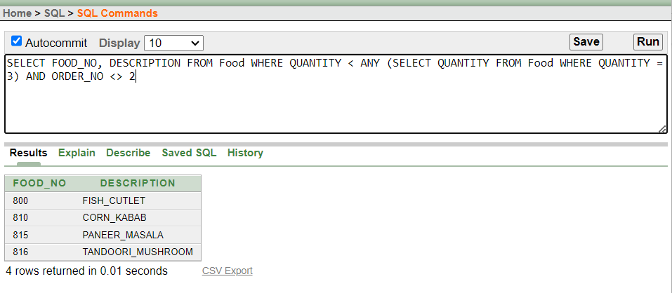

1. **Question:** Retrieve the Waiter Name (W_NAME) from the "Waiter" table for the waiter associated with the customer whose name is 'DIBBO'.

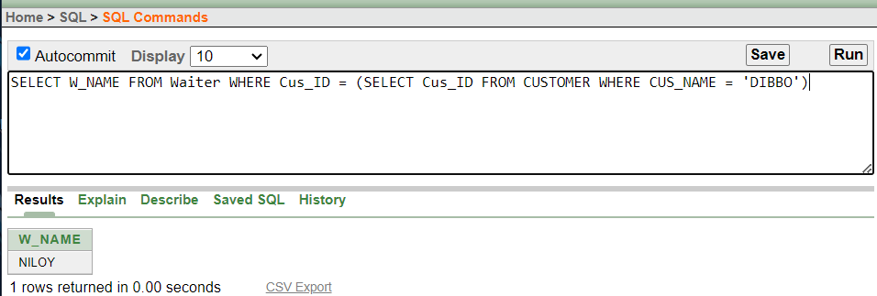

**Joining**

1. **Question:** Retrieve the Customer Name, Customer Contact, and Restaurant Name by joining the "Customer" table (C) with the "Restaurant" table (R) using the common column R_ID.

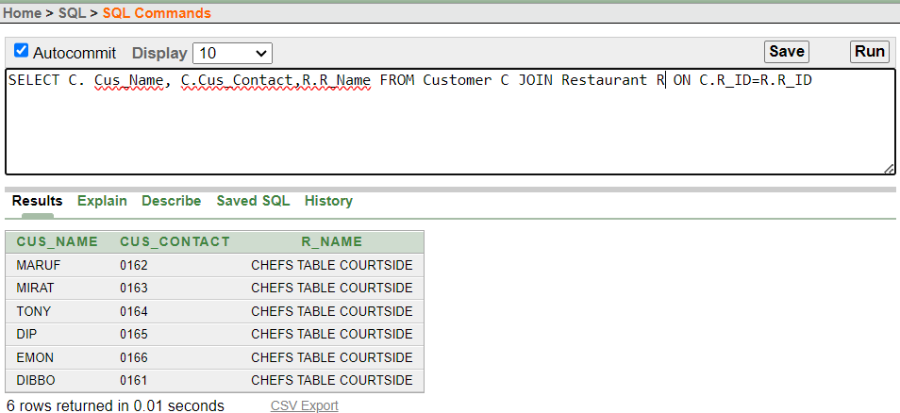

1. **Question:** Retrieve the Waiter ID and Waiter Name by joining the "Waiter" table (W) with the "Food" table (F) using the common column ORDER_NO.

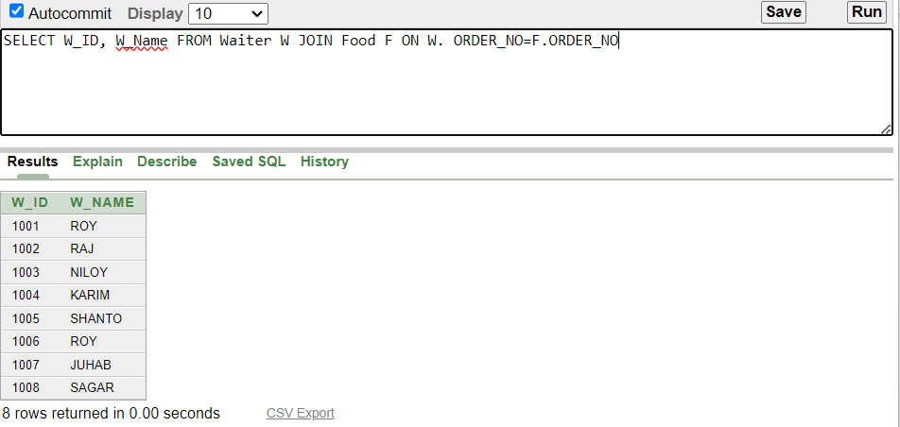

1. **Question:** Retrieve the details of food items, including their (Food_NO), (Quantity), (Description), (No_Items), and (Ord_Time). Include all food items, even those that do not have corresponding entries in the OrderINFO table.

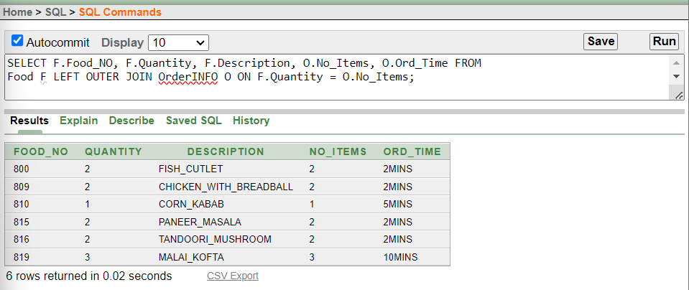

1. 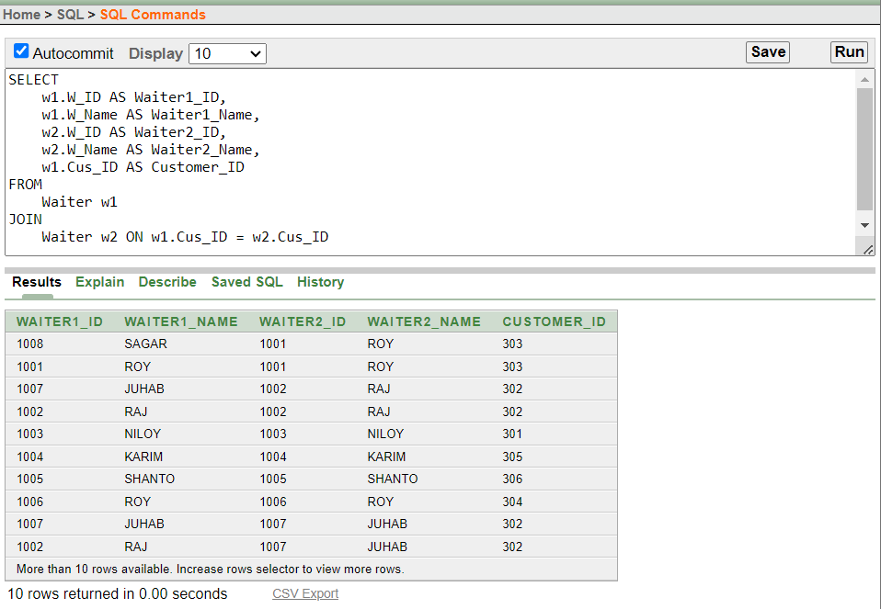**Question:** Provide pairs of waiters and their corresponding customer IDs who have served the same customer? The list should include the IDs and names of both waiters, along with the shared customer ID. If a waiter hasn't served alongside another waiter for the same customer, that pair won't be included in the result.

## SIMPLE VIEW

1. **Question:** Create a view that presents essential information about waiters, including their IDs, names, associated customer IDs, and order numbers.



1. **Question:** Provide a view that shows the waiter ID, waiter name, manager name, and manager ID for each waiter who is managed by a specific manager.

# Conclusion

In summary, the Restaurant Management System database project is a powerful tool that brings efficiency, accuracy, and enhanced customer satisfaction to restaurant operations. It contributes to the overall success and growth of the business by providing a well-organized and technology-driven approach to management.